EE 432
RF Engineering for Telecommunications

Lab #5
Diffraction

Name: Mohammad Chahardori (Student ID: 11632753)
Partner: Richard Osorio

Due Date: 10/07/2020

Description of the Experiment
Purpose:
In this lab we are going to experiment, analyze and understand the effect of diffraction in Wireless communication channel.
Procedure:
The data provided for us shows that one corner of a building in campus was chosen to be the diffracting obstacle in this experiment. A transmitter 915 MHz was set on a fixed-point at height $h_{t}=3.3 feet=1m.$ The experiment setup is shown in figure 1.
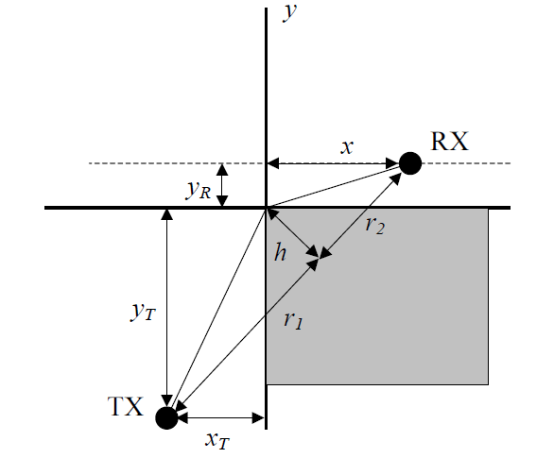
Figure 1: Experimental setup for the lab
According to the data provided,
$y_{T}={39}^{'}7^{''},$ $x_{T}=12.5'$, $y_{R}=5'$
The transmitter is located at point ($x_{T}, y_{T}).$A field strength meter is used to measure the received power at $\left(x,y_{R}\right)=(x,5)$ for different values of x, starting from $x=x_{T}$ and moving to the right by 2’steps. The receiver height is $h_{R}=5^{'}7^{''}=1.733m$

Data Analysis:
The measured received power with distance is given in table 1.
Table 1: Received data with vs x distance
Distance, x (ft) | Distance, x (m) | Received Power (dBm)
0 | 0 | -42
2 | 0.6096 | -41
4 | 1.2192 | -46
6 | 1.8288 | -38
8 | 2.4384 | -39
10 | 3.0480 | -40
12 | 3.6576 | -36
14 | 4.2672 | -41
16 | 4.8768 | -48
18 | 5.4864 | -53
20 | 6.0960 | -69
22 | 6.7056 | -55
24 | 7.3152 | -51
26 | 7.9248 | -53
28 | 8.5344 | -62
30 | 9.1440 | -56
32 | 9.7536 | -67
34 | 10.3632 | -66

- Fitting to a Free Space Propagation Model:
In the first part we have tried to fit the measured data using free space propagation model. In this part we tried to find the optimum P₀ to have the minimum variance between the receive data and the data calculated based on the model in equation (1) for the data set wich are measured when there is a line of sight. Since $x_{T}=12.5'$ , just the first 7 measured power which are relative to $x_{}<12.5'$ are considered for data fitting to free space propagation model in this section. We consider n=2 due to free space propagation in (1). we have used a MATLAB file (A.1) to show the results from the measurement and the results according to the free space model.
$P_{f}=P_{0}-10n\log\left(\frac{r}{r_{0}}\right)$ (1)
The fitted information is given below:
$$P_{0}=-40 dBm,$$
$σ=1.89 dB,$ (regarding just the measured powers for $x_{}<12.5'$ )
$σ_{total_points}=13.5 dB,$ (regarding all the measured powers)
In figure 2 , the measured powers and the calculated power based on free space model in equation (1) are shown together. As we can see in the figure 2, and also as it is realized according to $σ_{total_points}=13.5,$ the free space model cannot properly model the behavior of received signal especially for the points where there is no line of sight between receiver and transmitter and as a result free space model cannot estimate the loss due to diffraction. So we need a better model to calculate the behavior of this communication channel.
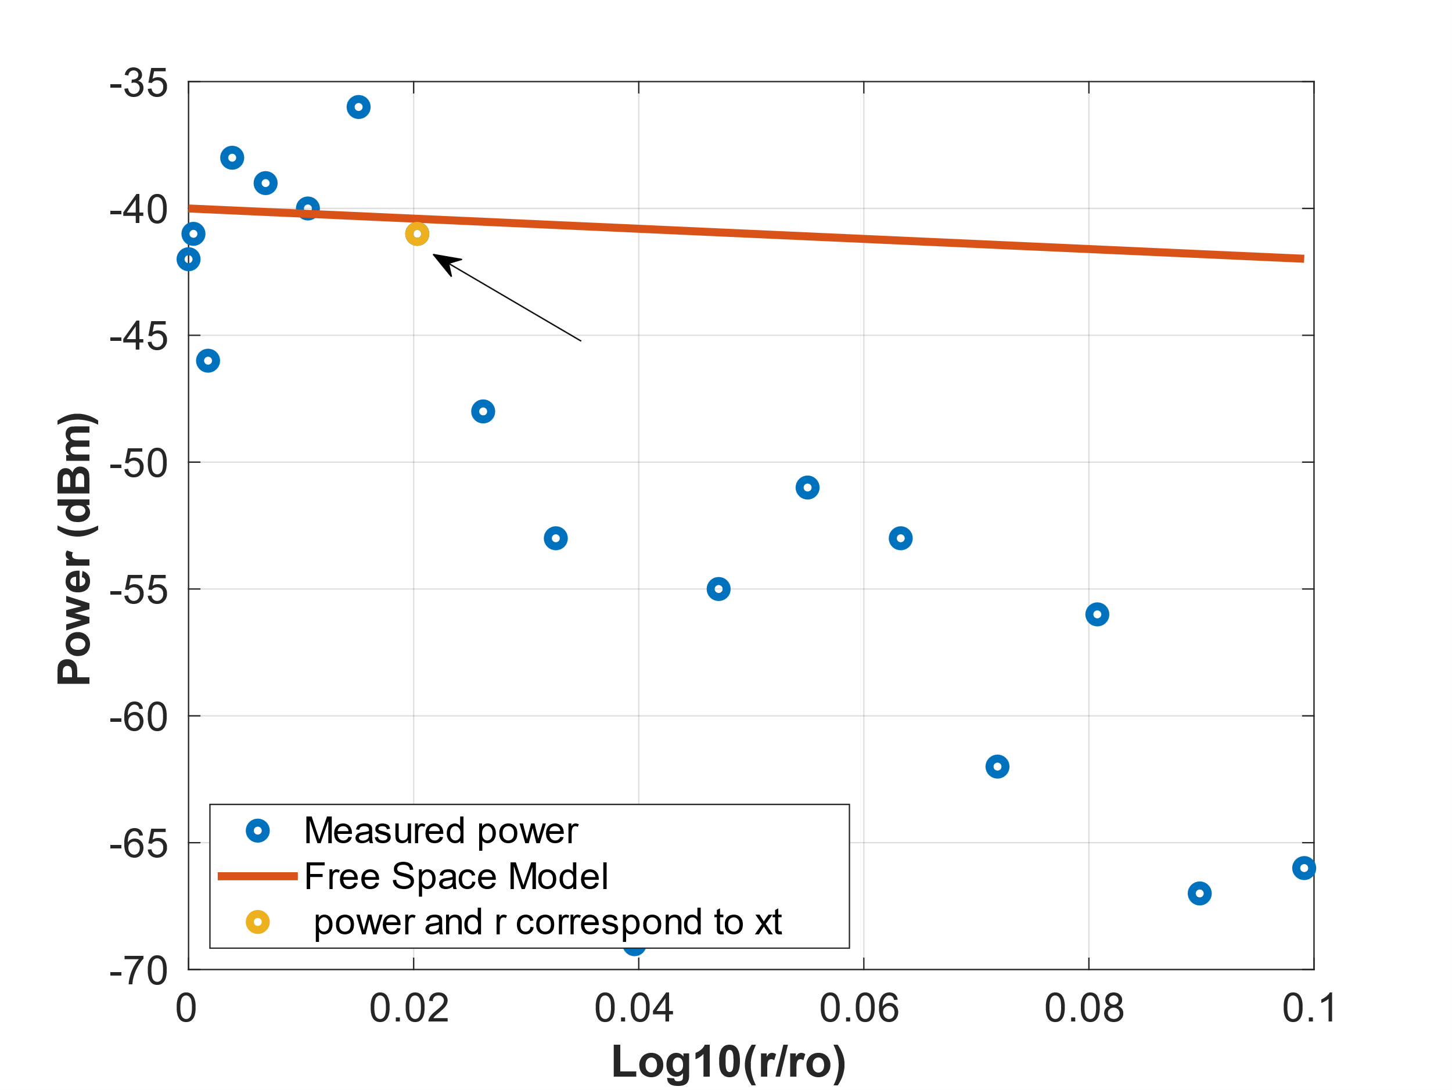
Figure 2: Free Space Modelling and the measured data
- Diffraction:
Based on the measurement setup, the diffraction gains for each point have been calculated using MATLAB code A2. In this Matlab code we first calculated angle Theta and Phi and Psi based on the geometry of the experiment (measurement) and using the formulas for calculating the U and diffraction gain (Gd) to calculate the diffraction gain and received power regarding each distance in the measurement.
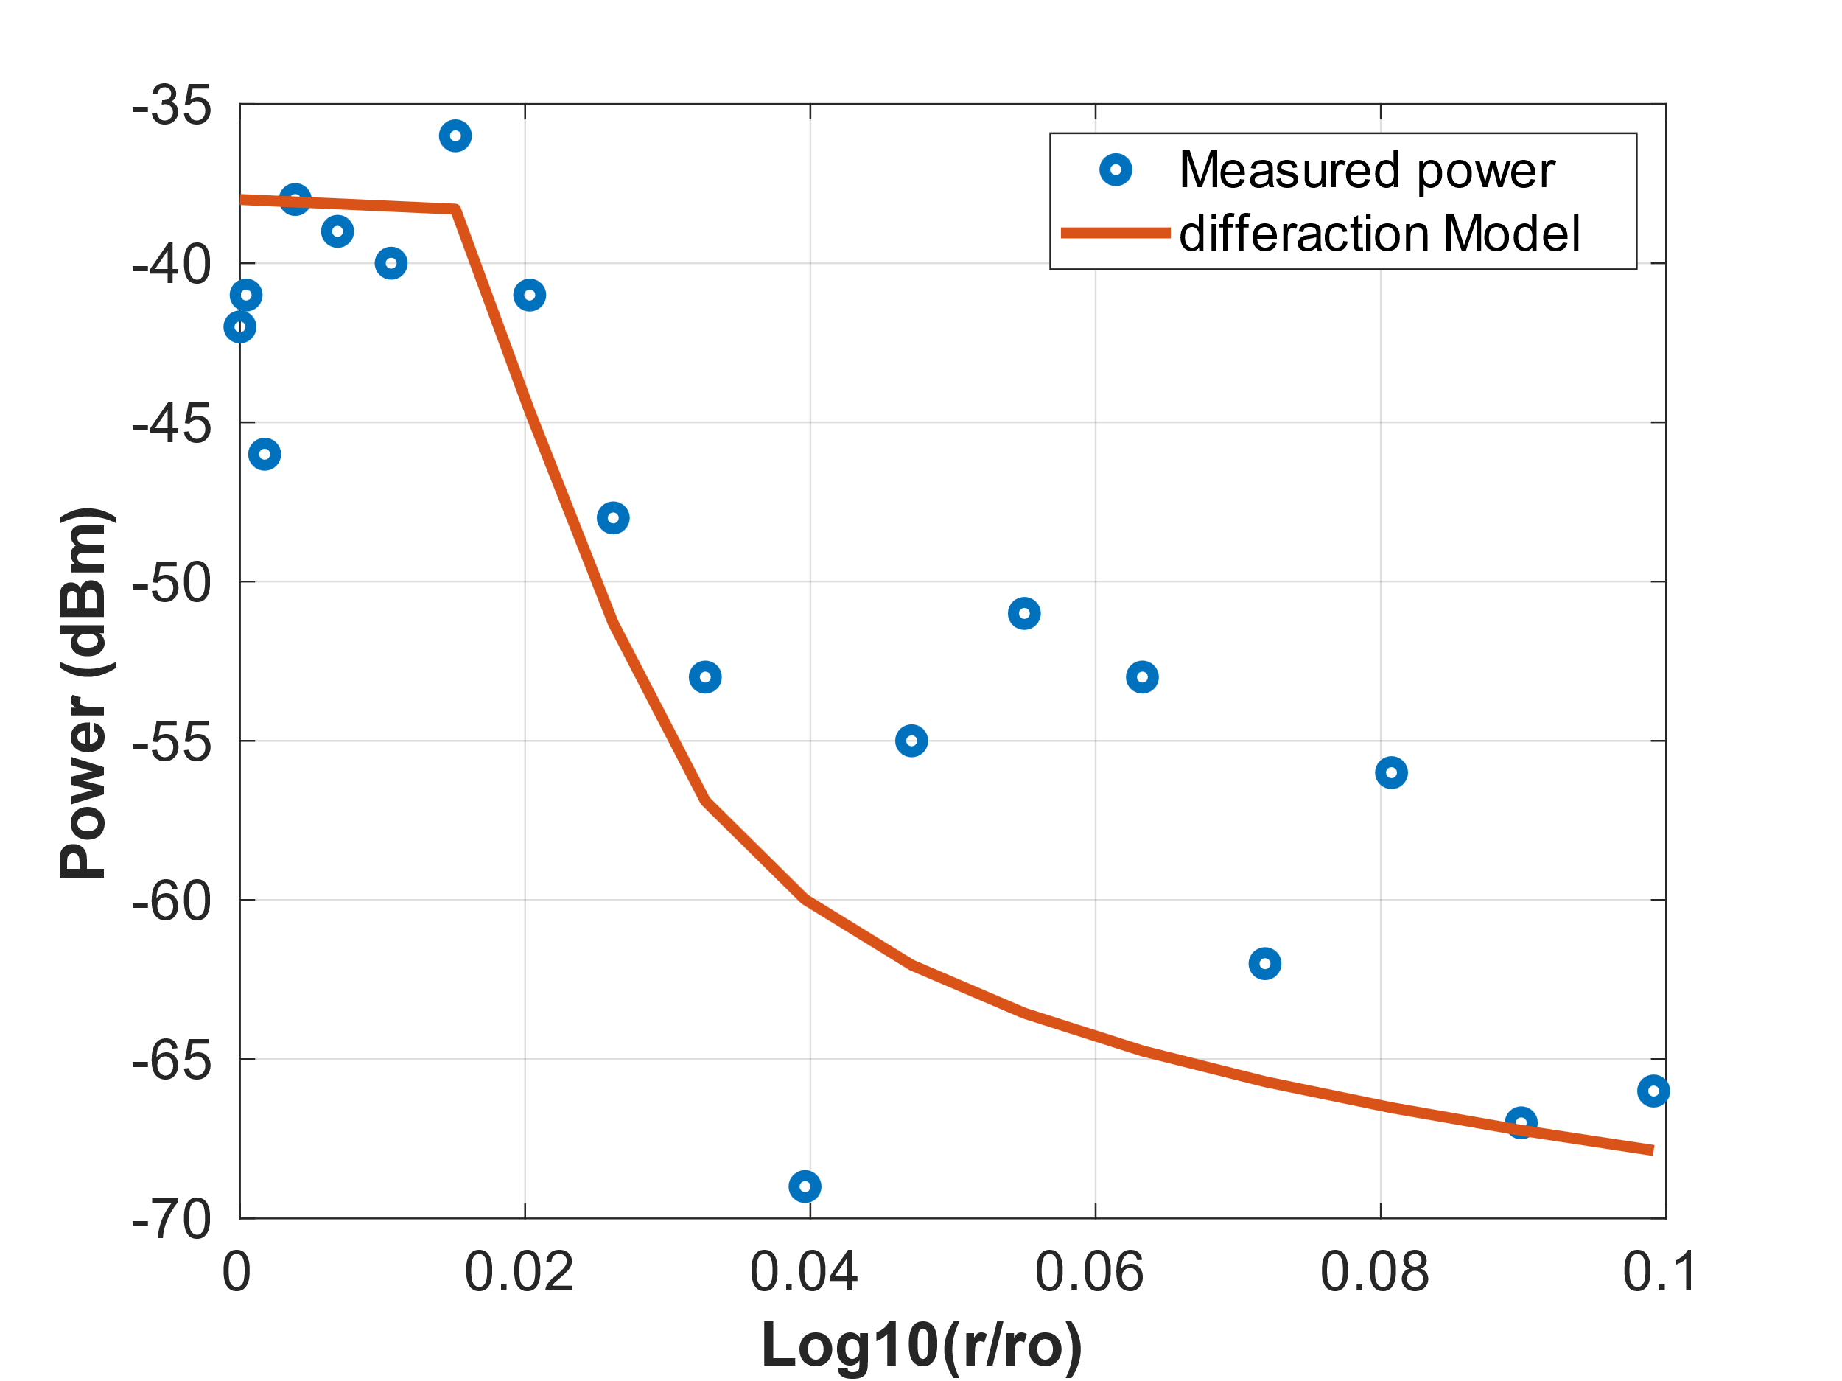
Figure 3, shows the output plot based on the code A2:

Figure 3: Measured data vs model including diffraction
We can see from the graph that the model agrees properly with the measured data. For this model, we achieved the optimum $P_{0}= -38 dBm$. The standard deviation is 2.2 dB.
$$P_{0}=-38 dBm, σ=2.2 dB$$
Also in figure 3 we can see that the diffraction model has a little inaccuracy in estimating the received power and shows more loss which is mostly because of the power passing through the building which is not considered by the diffraction model.
- Transmission Through building
In this step, we try to provide more accurate model by considering and adding the power passing through the building to our final model. For $u≤0,$ only diffraction model is considered. For $u>0,$ attenuated version of the free space propagation is added to the model from $P_{t}=P_{0}-10n\log\left(\frac{r}{r_{0}}\right)-AF$. Here, AF is the attenuation factor. We found for the same $P_{0}= -38 dBm$ and by considering $AF= 17dB$, we obtain a more accurate fit which is shown below:
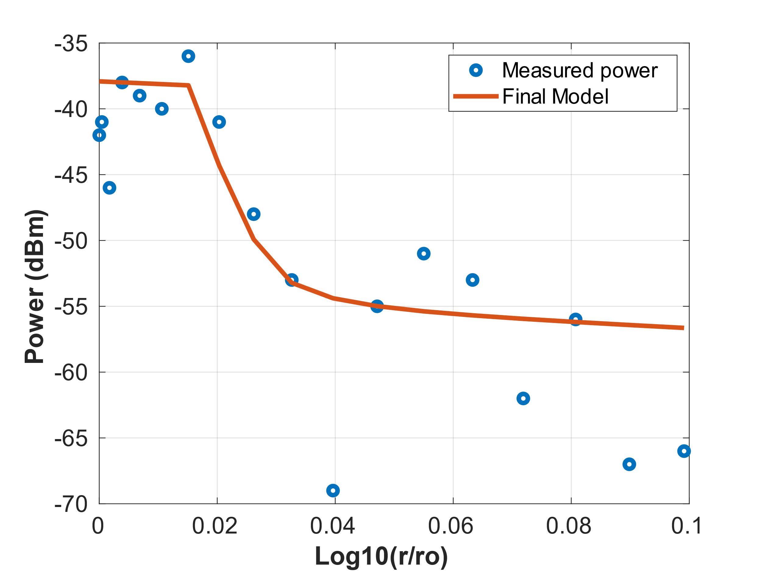
Figure 4: Measured data vs model including diffraction and transmission through the building
The fitted information is given below:
$$P_{0}=-38 dBm, σ=2.02$$
It appears that we obtained a better fit before adding the attenuation factor. The reason behind this inconsistency is the measurements of the higher distance points.
Conclusion:
In this experiment we realized that the free space model cannot estimate and calculate the power when we don't have a line of sight and there's an obstacle between transmitter and receiver in the wireless communication channel, also we realize that the diffraction model can estimate properly the effect of a sharp edge obstacle when we don't have line of sight. At last, when we consider both diffraction and also the power which is passing through the non-ideal conducting material like concrete (building) we can achieve have a good model which comply with the measurements properly.
Appendix A.1
Code for the free space model:
clc;
clear all
close all
%parameters
hr=5.7; %ft
ht=3.3; %ft
yr=5; %ft
yt=39.7;%ft
xt=12.5; %ft
f = 915; %MHz

%data
Power_Received = [-42,-41,-46,-38,-39,-40,-36,-41,-48,-53,-69,-55,-51,-53,-62,-56,-67,-66]; %Rx'd power in dBm
x = (0:2:34); %measurements taken every 2 ft,starting from xt.
N = length(Power_Received);
%++++++++++++++++++++++++++++++++++++++++++++++++++++
% Determination of Distances between the Rx and TXs
%++++++++++++++++++++++++++++++++++++++++++++++++++++
r0 = yr + yt;
r = sqrt((x).^2 + (yr + yt)^2);
%++++++++++++++++++++++++++++++++++++++++++++++++++++++++++++
% Calculation of power and sigma from the free space model
%++++++++++++++++++++++++++++++++++++++++++++++++++++++++++++
P0 = -40;
n = 2;
Power_Free_Space_dBm = P0 - 10*n* log10(r/r0);

sigma_square_free_space = sum((Power_Received(1:7) - Power_Free_Space_dBm(1:7)).^2) /(N);
sigma_free_space = sqrt(sigma_square_free_space)

%++++++++++++++++++++++++++++++++++++++++++++++++++++++++++++
% Plotting the Result
%++++++++++++++++++++++++++++++++++++++++++++++++++++++++++++
figure
plot(log10(r/r0),Power_Received,'o',"LineWidth",3)
ylabel('Power (dBm)','fontweight','bold','fontsize',16);
xlabel('Log10(r/ro)','fontweight','bold','fontsize',16)
set(gca,'FontSize',15)
grid on
hold on;
plot(log10(r/r0),Power_Free_Space_dBm,'LineWidth',3)
plot(log10(r(8)/r0),Power_Received(8),'o',"LineWidth",3)
legend('Measured power', 'Free Space Model', ' power and r correspond to xt','Location','southwest','NumColumns',1)

Appendix A2
Code for the diffraction model:
clc;
clear all
close all
%parameters
hr=5.7; %ft
hr=5.7*0.3048;

ht=3.3; %ft
ht=3.3*0.3048; %meter

yr=5; %ft
yr=5*0.3048; %meter

yt=39.7;%ft
yt=39.7*0.3048; %meter

xt=12.5; %ft
xt=12.5*0.3048; %meter

f = 915; %MHz
lambda = 300/f ; % wavelength

%data
Power_Received = [-42,-41,-46,-38,-39,-40,-36,-41,-48,-53,-69,-55,-51,-53,-62,-56,-67,-66]; %Rx'd power in dBm
x = (0:2:34); %measurements taken every 2 ft,starting from xt.
x = (0:2:34)*0.3048; % measuring distances in meter
N = length(Power_Received);
%++++++++++++++++++++++++++++++++++++++++++++++++++++
% Determination of Distances between the Rx and TXs
%++++++++++++++++++++++++++++++++++++++++++++++++++++
r0 = yr + yt;
r = sqrt((x).^2 + (yr + yt)^2);
%++++++++++++++++++++++++++++++++++++++++++++++++++++++++++++
% Determination of the required angles between the Rx and TXs
%++++++++++++++++++++++++++++++++++++++++++++++++++++++++++++
theta = atan(yt/xt) - atan((yt+yr)./(x)) % calculating theta values
psi = atan((yt+yr)./(x))
phi = atan((yt+yr)./(x)) - atan(yr./(x-xt))

%++++++++++++++++++++++++++++++++++++++++++++++++++++++++++++
% Determination of the U based on theta and phi
%++++++++++++++++++++++++++++++++++++++++++++++++++++++++++++
for i = 1: N
if theta(i) < 0
u(i) = -1*sqrt(2*r(i)*abs(tan(theta(i))*tan(phi(i)))/lambda);
else
u(i) = sqrt(2*r(i)*abs(tan(theta(i))*tan(phi(i)))/lambda);
end
end
%++++++++++++++++++++++++++++++++++++++++++++++++++++++++++++
% Determination of Differaction Gain Gd
%++++++++++++++++++++++++++++++++++++++++++++++++++++++++++++

for i=1:length(u)
if u(i) <= -1
Gd(i) = 0;
elseif (u(i) <= 1) && (u(i) > -1)
Gd(i) = -6.5 * (u(i)+1);
else
Gd(i) = 20*log10(1/(sqrt(2)*pi*u(i)));
end
end

%++++++++++++++++++++++++++++++++++++++++++++++++++++++++++++
% Calculation of the power with differaction and sigma
%++++++++++++++++++++++++++++++++++++++++++++++++++++++++++++

P0 = -38; % P0 for curve fitting
Power_with_diffraction = P0-10*2*log10(r/r0) + Gd;
sigma_square = sum(abs(Power_Received - Power_with_diffraction)) /(N)
sigma = sqrt(sigma_square)
Gd = Gd;

%++++++++++++++++++++++++++++++++++++++++++++++++++++++++++++
% Plotting the Result
%++++++++++++++++++++++++++++++++++++++++++++++++++++++++++++
figure
plot(log10(r/r0),Power_Received,'o',"LineWidth",3)
ylabel('Power (dBm)','fontweight','bold','fontsize',16);
xlabel('Log10(r/ro)','fontweight','bold','fontsize',16)
set(gca,'FontSize',15)
grid on
hold on;
plot(log10(r/r0),Power_with_diffraction,'LineWidth',3)

Appendix A3
Code for the diffraction model including attenuation factor:

clc;
clear all
close all
%parameters
hr=5.7; %ft
hr=5.7*0.3048; %meter

ht=3.3; %ft
ht=3.3*0.3048; %meter

yr=5; %ft
yr=5*0.3048; %meter

yt=39.7;%ft
yt=39.7*0.3048; %meter

xt=12.5; %ft
xt=12.5*0.3048; %meter

f = 915; %MHz
lambda = 300/f ; % wavelength

%data
Power_Received = [-42,-41,-46,-38,-39,-40,-36,-41,-48,-53,-69,-55,-51,-53,-62,-56,-67,-66]; %Rx'd power in dBm
x = (0:2:34); %measurements taken every 2 ft,starting from xt.
x = (0:2:34)*0.3048 % measuring distances in meter
N = length(Power_Received);

%++++++++++++++++++++++++++++++++++++++++++++++++++++
% Determination of Distances between the Rx and TXs
%++++++++++++++++++++++++++++++++++++++++++++++++++++

r0 = yr + yt;
r = sqrt((x).^2 + (yr + yt)^2);

%++++++++++++++++++++++++++++++++++++++++++++++++++++++++++++
% Determination of the rquired angles between the Rx and TXs
%++++++++++++++++++++++++++++++++++++++++++++++++++++++++++++

theta = atan(yt/xt) - atan((yt+yr)./(x)) % calculating theta values
psi = atan((yt+yr)./(x))
phi = atan((yt+yr)./(x)) - atan(yr./(x-xt))

%++++++++++++++++++++++++++++++++++++++++++++++++++++++++++++
% Determination of the U based on theta and phi
%++++++++++++++++++++++++++++++++++++++++++++++++++++++++++++
for i = 1: N
if theta(i) < 0
u(i) = -1*sqrt(2*r(i)*abs(tan(theta(i))*tan(phi(i)))/lambda);
else
u(i) = sqrt(2*r(i)*abs(tan(theta(i))*tan(phi(i)))/lambda);
end
end

%++++++++++++++++++++++++++++++++++++++++++++++++++++++++++++
% Determination of Differaction Gain Gd
%++++++++++++++++++++++++++++++++++++++++++++++++++++++++++++
for i=1:N
if u(i) <= -1
Gd(i) = 0;
elseif (u(i) <= 1) && (u(i) > -1)
Gd(i) = -6.5 * (u(i)+1);
else
Gd(i) = 20*log10(1/(sqrt(2)*pi*u(i)));
end
end

%+++++++++++++++++++++++++++++++++++++++++++++++++++++++++++++++++++
% Determination of power through obstacle and power due to differaction
%+++++++++++++++++++++++++++++++++++++++++++++++++++++++++++++++++++
P0 = -38; % optimum P0 for curve fitting
AF = 17; % optimum AF for curve fitting
for i=1:N
if u(i) <= 0
Power_through_obstacle = -300; % assigning very small power in dBm
else
Power_through_obstacle = P0-10*2*log10(r/r0) - AF;
end
end

Power_with_diffraction = P0-10*2*log10(r/r0) + Gd;

%++++++++++++++++++++++++++++++++++++++++++++++++++++++++++++
% Calculation of the total power and sigma
%++++++++++++++++++++++++++++++++++++++++++++++++++++++++++++

Power_total = 10 * log10 (10.^(Power_with_diffraction/10)+10.^(Power_through_obstacle/10))
sigma_square = sum(abs(Power_Received - Power_total)) /(N)
sigma = sqrt(sigma_square)
Gd = Gd;
Power_through_obstacle = Power_through_obstacle;
%++++++++++++++++++++++++++++++++++++++++++++++++++++++++++++
% Plotting the Result
%++++++++++++++++++++++++++++++++++++++++++++++++++++++++++++
figure
plot(log10(r/r0),Power_Received,'o',"LineWidth",3)
ylabel('Power (dBm)','fontweight','bold','fontsize',16);
xlabel('Log10(r/ro)','fontweight','bold','fontsize',16)
set(gca,'FontSize',15)
grid on
hold on;
plot(log10(r/r0),Power_total,'LineWidth',3)

